Communities and NHS Fife | 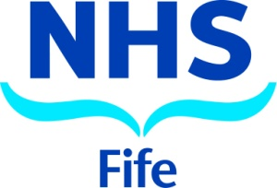
Community Empowerment (Scotland) Act 2015
Annual Asset Transfer Review

April 2021 to April 2022

During this period, one asset transfer was received by NHS Fife

Property Address | Community Transfer Body | Initial Request Date | Validation Date | Size (Ha) | Type – Owned or Leased | Proposed Use | Outcome | Date of Outcome | Status
Land at Stratheden Hospital and former mortuary building | Lucky Ewe | 17/9/2021 updated from 10/2020 | 22/11/21 | 28.9 | Owned | Sheep husbandry, farming, food production, learning opportunities for people needing additional support | - | - | Pending

